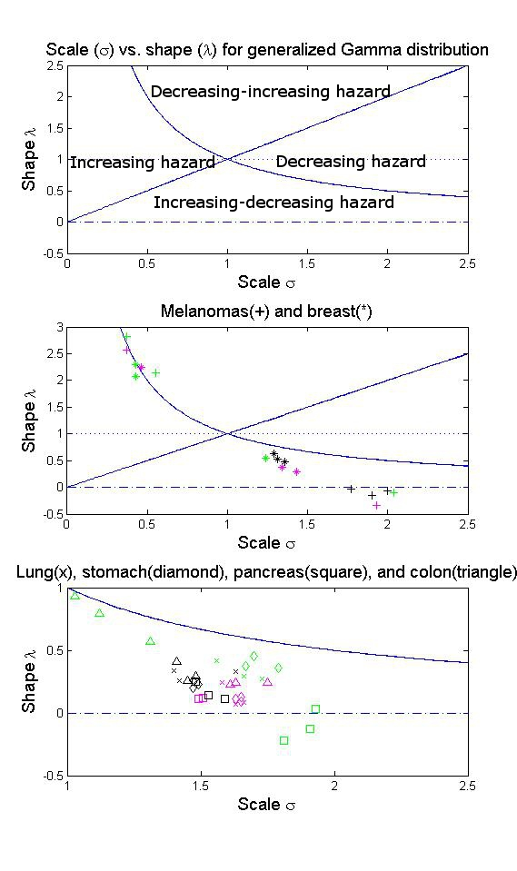

Introduction.
We implemented the taxonomy of hazard functions for the generalized gamma distribution in Cox et al., 2007, Statistics in Medicine to estimate the parameters and hazard change of the SEER data.

Text for panel 1.
Scale parameter (\sigma) vs. shape parameter (\lambda) plot for the generalized gamma distribution. Certain distributions lie on the corresponding lines. Weibull: \lambda=1; Lognormal: \lambda=0; Gamma: lambda = sigma; Ammag: lambda = 1/sigma.

Text for panel 2.
Estimates for melamonas and breast cancer in the three decades. Green: localized cancer; Pink: regional cancer; Black: distant cancer.

Text for panel 3.
Estimates for lung, stomach, pancreas, and colon cancers in the three decades. Green: localized cancer; Pink: regional cancer; Black: distant cancer.

Conclusion section:

Projection of the cancer survival to the plot of scale vs. shape parameters of the generalized gamma distribution helps visualize the hazard change, and provides insights into the further prediction of the survival for a specific type of cancer.

